SUBMISSION FORM
Please fill out this form and return it to info@esci-ksp.org. and d32375@tier.org.tw

Pillar
☐ Smart Transport
☐ Smart Building
☐ Smart Grids
☐ Smart Job and Consumers
■ Low Carbon Model Town

Basic Information
Program name: Please provide the program title. The title should be brief, unique, and informative.
The Solar City- Great Tainan

Responsible organization: Please enter the name of the responsible organization.
Economic Development Bureau, Tainan City Government

Strategy:Please refer to the attached criteria to provide further information.
The development of renewable energy that suits local demands needs to also consider the high density and crowded population in Taiwan. Due to the high value of land, we choose to make use of the idle spaces to install photovoltaic system as the main source to develop renewable energy. In 2011, the “Solar Power City” was launched with the goals to promote five items including solar public housing, solar roofs, solar communities, green factories, and agriculture greenhouses. Flush connection is used for tilt roofs, and trellis photovoltaic systems are installed on the dead-level roofs without any interruption of original spatial use of roofs.
In 2011, the Solar City Project was launched; the City Government provided comprehensive services for promotion (organization of seminars), counseling (services windows at different districts), subsidies (for financial encouragement), and application reviews. In coordination with the mandatory measures of autonomous regulations, the determination to build great Taiwan into a low carbon and green energy city was conveyed. For the promotion in the past four years, the Tainan City Government approved 1,795 solar energy installation and ten solar community applications with the capacity over 93 megawatts. In the future, the capacity is expected for a continuous growth to achieve the goal of building “the Solar City-Great Tainan” that reduces carbon emission and generates green energy.

Measure:Please refer to the attached criteria to provide further information.
- Building of Solar City Information Web
- Organization of more than 150 Seminars in Four Years
- Use of Residential Buildings without Participation in Tender Mechanism
- Enactment of Subsidy Measures for the Encouragement of Installation
- Seminars Organized at the Beginning of Each Year for Equipment Review Operation
- Inter-departmental Cooperation for Joint Strategy Promotion

Performance:Please refer to the attached criteria to provide further information.
According to statistics, from 2011 to 2014, the number of the installation of photovoltaic systems approved in Tainan City reached to 1,795 with the total capacities exceeding 93 MW and annual power generation capacities over 116.92 MW equivalent to 42.5% of electricity generated by Zengwen Reservoir that can supply for the use of 32,658 house units and reduce over 60,000 tons of carbon demission equivalent to that done by the annual reduced amount of 187 Tainan parks, occupied about 5,451 hectares and saving over NT$91.37 million.
After the effort of another eight months, by August 31, 2015, Tainan City had 2,596 approved PV installation applications with the capacity of 144 Mw and annual power generation of 180.41 million Kwh equivalent to 65.61% of power generated by Zenwen Reservoir as well as the carbon emission reduction over 93,000 tons, equivalent to the reduction done by 289 Tainan Metropolitan Parks. We are continuously improving.
APEC Economies:
☐ Australia
☐ Brunei
☐ Canada
☐ Chile
☐ China
■ Chinese Taipei
☐ Hong Kong
☐ Indonesia
☐ Japan
☐ Korea
☐ Malaysia
☐ Mexico
☐ New Zealand
☐ Non-APEC Economy
☐ Papua New Guinea
☐ Peru
☐ Philippines
☐ Russia
☐ Singapore
☐ Thailand
☐ United States
☐ Viet Nam
Additional Project Details
Image: Please attach an image that represents this project, if one is available, to this email.
Fig. 3: Global Temperature Changes
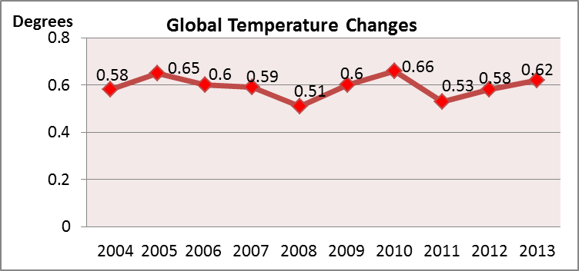

Fig.4: Temperature Changes in Taiwan
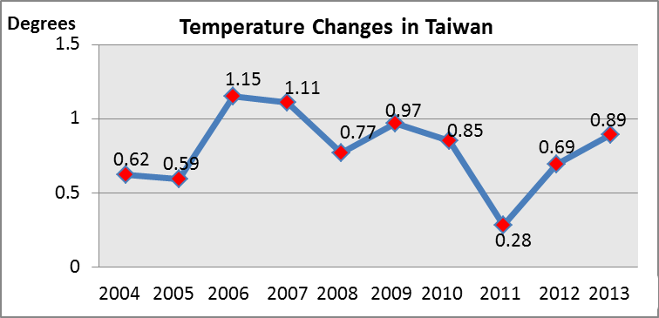

Fig. 6: Taiwan’s Electricity Composition in 2014
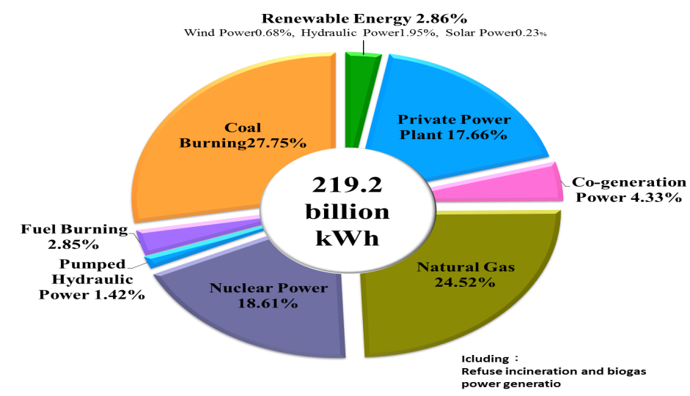

Fig. 7: Tainan Being #1 according to Statistics of Annual Electricity Generation from the Photovoltaic System per KW Conducted by Bureau of Energy
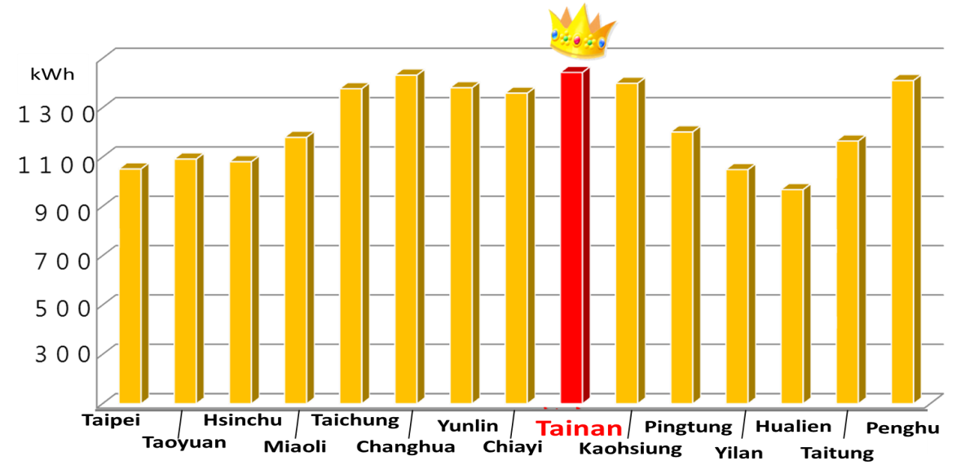

Fig. 8: Tainan’s Comprehensive Solar Power Industrial Chain
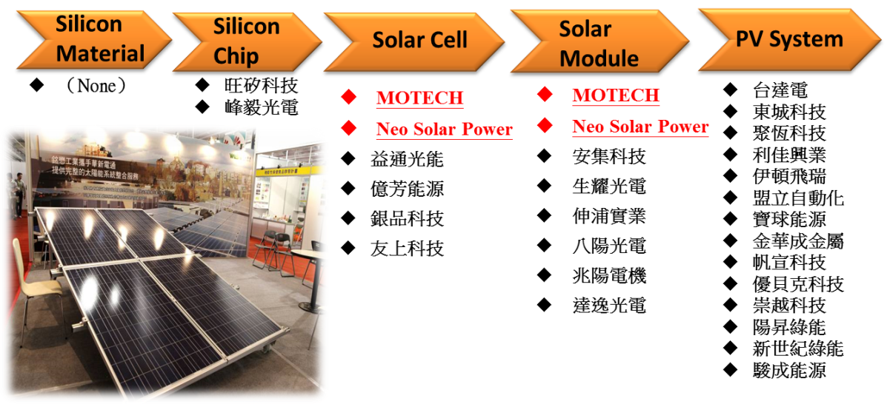

Upload:
Please attach a file associated with your project (e.g. pdf, ppt, video or image files) to this email.
Video（English）
Website:
Enter a project website.
http://solarcity.tainan.gov.tw/
（Next year we plan to build English website.）
Contact Information
Contact Name: Please enter your name so ESCI users can contact you with questions.
Energy Section of the Bureau of Economic Development, Tainan City Government
Contact Email: Please enter your email address so ESCI users can contact you with questions.
vchen24@mail.tainan.gov.tw

